ADVANCED MOBILE PROGRAMMING
JOURNAL

PRACTICAL 1
Aim- Introduction to Android, Introduction to Android Studio IDE, Application
Fundamentals: Creating a Project, Android Components, Activities, Services,
Content Providers, Broadcast Receivers, Interface overview, Creating Android
Virtual device, USB debugging mode, Android Application Overview. Simple
“Hello World” program.

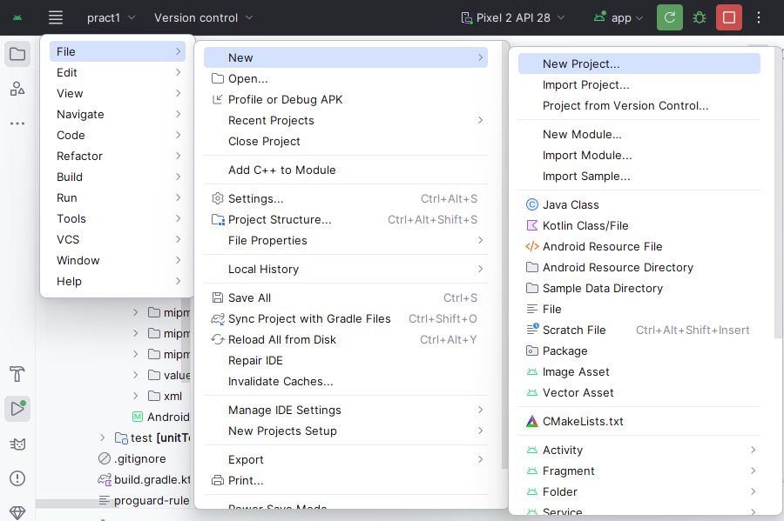

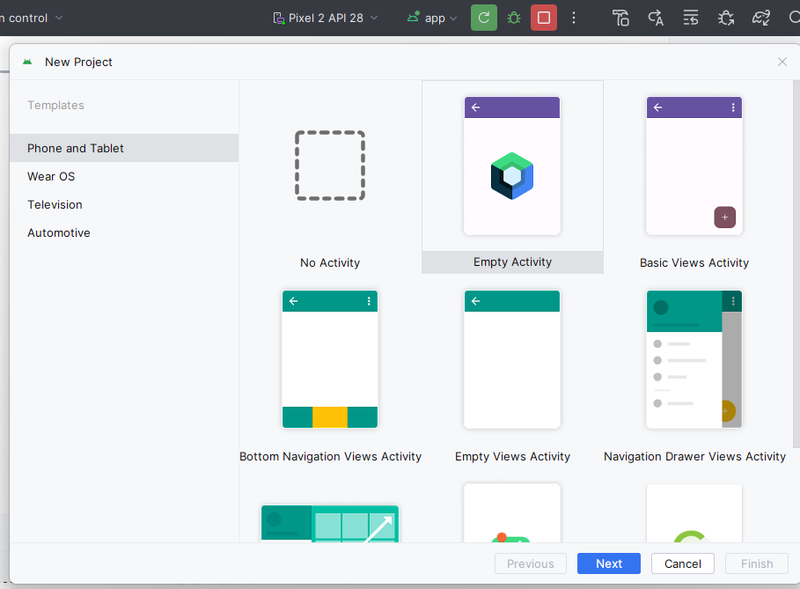

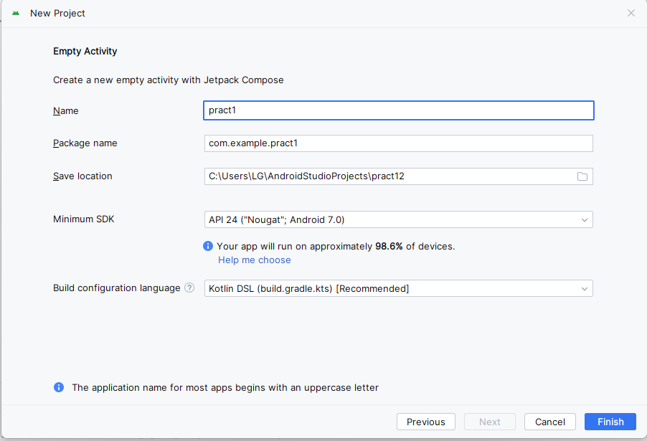

Go to app/src/main/java/MainActivity.kt
Code:
package com.example.pract1
import android.os.Bundle
import androidx.activity.ComponentActivity
import androidx.activity.compose.setContent
import androidx.compose.foundation.layout.Box
import androidx.compose.foundation.layout.fillMaxSize
import androidx.compose.material3.MaterialTheme
import androidx.compose.material3.Surface
import androidx.compose.material3.Text
import androidx.compose.ui.Alignment
import androidx.compose.ui.Modifier
import androidx.compose.runtime.Composable
import androidx.compose.ui.tooling.preview.Preview
import com.example.pract1.ui.theme.Pract1Theme
class MainActivity : ComponentActivity() {
override fun onCreate(savedInstanceState: Bundle?) {
super.onCreate(savedInstanceState)
setContent {
Pract1Theme {
// A surface container using the background color from the theme
Surface(
modifier = Modifier.fillMaxSize(),
color = MaterialTheme.colorScheme.background
) {
// Call the composable function that shows "Hello World!"
HelloWorld()
}
}
}
}
}
@Composable
fun HelloWorld() {
// Center the text in the screen
Box(
modifier = Modifier.fillMaxSize(),
contentAlignment = Alignment.Center
) {
Text(
text = "Hello, This is Assistant professor Janhavi",
style = MaterialTheme.typography.headlineMedium
)
}
}
@Preview(showBackground = true)
@Composable
fun HelloWorldPreview() {
Pract1Theme {
HelloWorld()
}
}
Click on run app
Output-
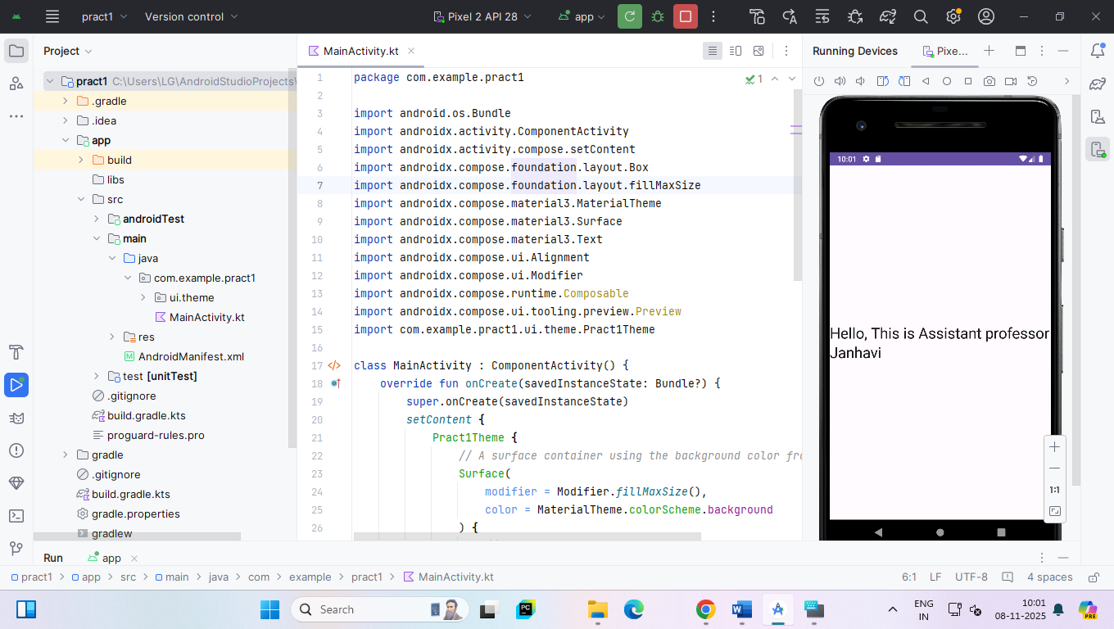
PRACTICAL 2
Aim- Programming Resources Android Resources: (Color, Theme, String, Drawable, Dimension, Image)
Code:
MainActivity.kt
package com.example.pract2
import android.os.Bundle
import androidx.activity.ComponentActivity
import androidx.activity.compose.setContent
import androidx.compose.foundation.Image
import androidx.compose.foundation.layout.*
import androidx.compose.material3.MaterialTheme
import androidx.compose.material3.Surface
import androidx.compose.material3.Text
import androidx.compose.runtime.Composable
import androidx.compose.ui.Modifier
import androidx.compose.ui.res.colorResource
import androidx.compose.ui.res.painterResource
import androidx.compose.ui.res.stringResource
import androidx.compose.ui.text.font.FontWeight
import androidx.compose.ui.tooling.preview.Preview
import androidx.compose.ui.unit.dp
import androidx.compose.ui.unit.sp
import com.example.pract2.ui.theme.Pract2Theme
import com.example.pract2.R
class MainActivity : ComponentActivity() {
override fun onCreate(savedInstanceState: Bundle?) {
super.onCreate(savedInstanceState)
setContent {
Pract2Theme {
Surface(
modifier = Modifier.fillMaxSize(),
color = colorResource(id = R.color.backgroundColor)
) {
Greeting("Android")
}
}
}
}
}
@Composable
fun Greeting(name: String, modifier: Modifier = Modifier) {
Column(
modifier = modifier
.fillMaxSize()
.padding(16.dp),
verticalArrangement = Arrangement.Center
) {
// Display image
Image(
painter = painterResource(id = R.drawable.android),
contentDescription = "Android Logo",
modifier = Modifier
.fillMaxWidth()
.height(150.dp)
)
Spacer(modifier = Modifier.height(24.dp))
// Use string and color resources
Text(
text = stringResource(id = R.string.greeting_text, name),
color = colorResource(id = R.color.textColor),
fontSize = 24.sp,
fontWeight = FontWeight.Bold
)
}
}
@Preview(showBackground = true)
@Composable
fun GreetingPreview() {
Pract2Theme {
Greeting("Android")
}
}

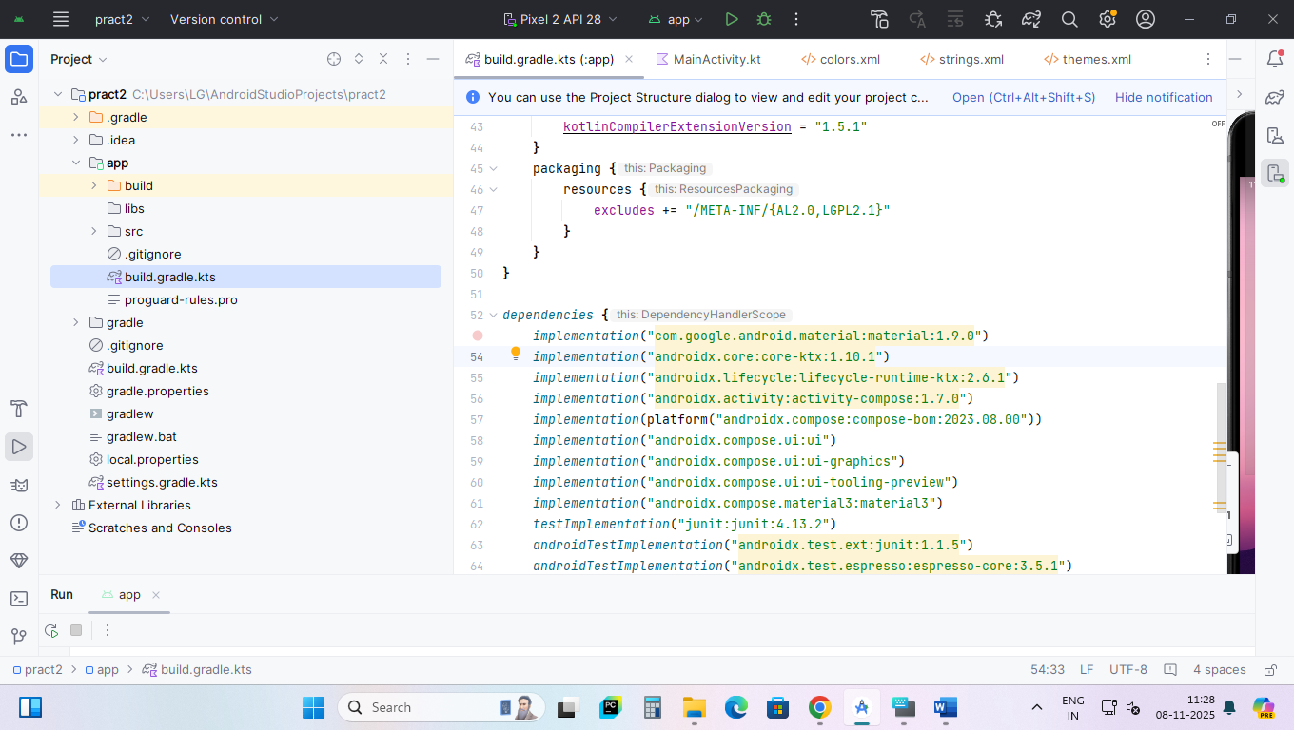
Open build.gradle.kts
Add this line -> implementation("com.google.android.material:material:1.9.0")
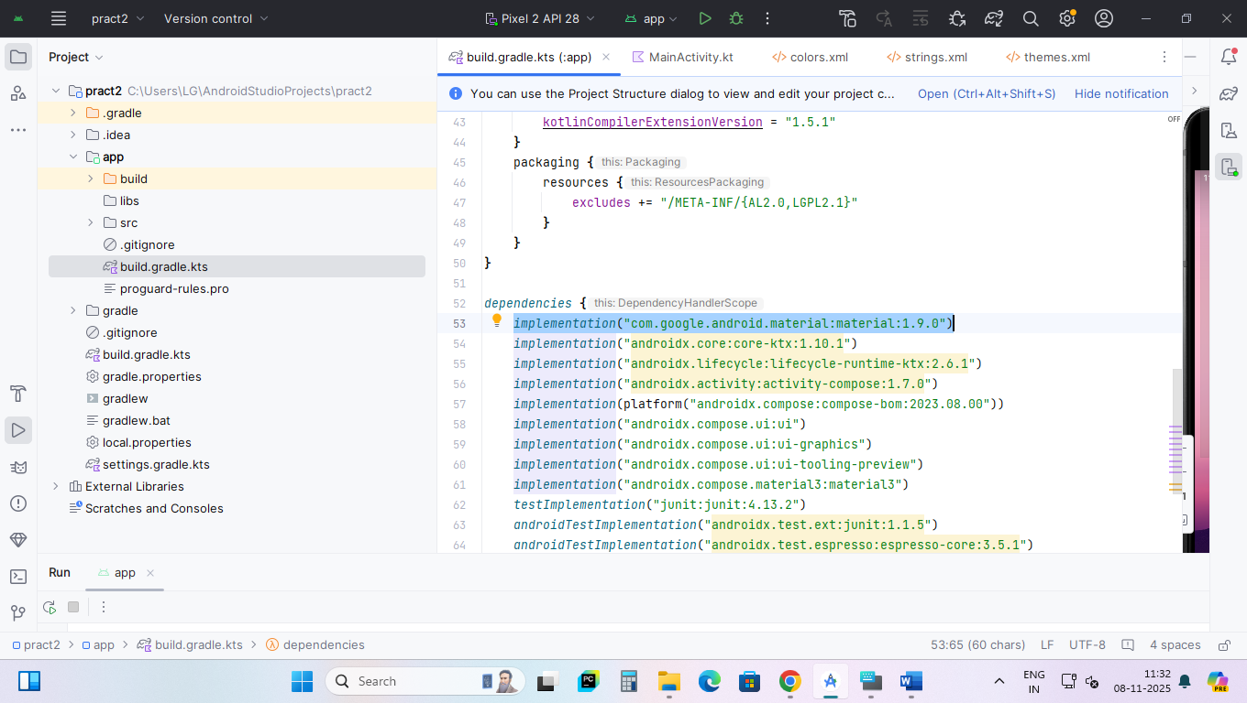

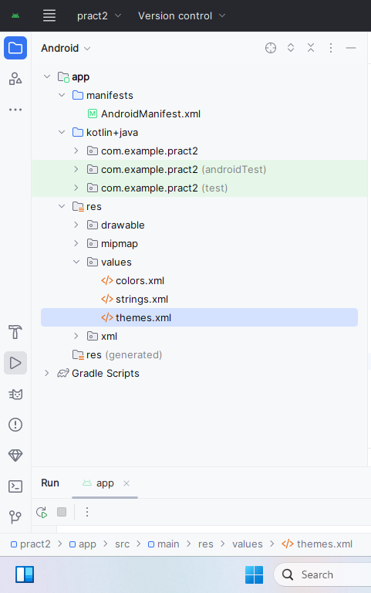
Open colors.xml
<resources>
<!-- Primary colors -->
<color name="purple_500">#6200EE</color>
<color name="purple_700">#3700B3</color>
<!-- Secondary colors -->
<color name="teal_200">#03DAC5</color>
<color name="teal_700">#018786</color>
<!-- Common colors -->
<color name="white">#FFFFFF</color>
<color name="black">#000000</color>
<!-- Custom colors used in your Compose app -->
<color name="backgroundColor">#FFFFFF</color>
<color name="textColor">#000000</color>
</resources>
Open strings.xml
<resources>
<string name="app_name">Pract2</string>
<string name="greeting_text">Hello %1$s!</string>
</resources>
Open themes.xml
<resources xmlns:tools="http://schemas.android.com/tools">
<!-- Base application theme -->
<style name="Theme.Pract2" parent="Theme.MaterialComponents.DayNight.NoActionBar">
<!-- Primary brand color -->
<item name="colorPrimary">@color/purple_500</item>
<item name="colorPrimaryVariant">@color/purple_700</item>
<item name="colorOnPrimary">@color/white</item>
<!-- Secondary brand color -->
<item name="colorSecondary">@color/teal_200</item>
<item name="colorSecondaryVariant">@color/teal_700</item>
<item name="colorOnSecondary">@color/black</item>
<!-- Background & text colors for Compose usage -->
<item name="android:statusBarColor" tools:targetApi="l">?attr/colorPrimaryVariant</item>
<item name="android:windowBackground">@color/backgroundColor</item>
</style>
</resources>

Output:
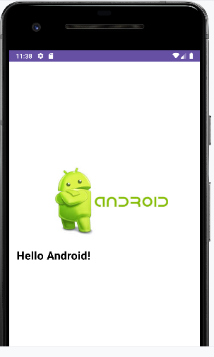

PRACTICAL 3
Aim-

